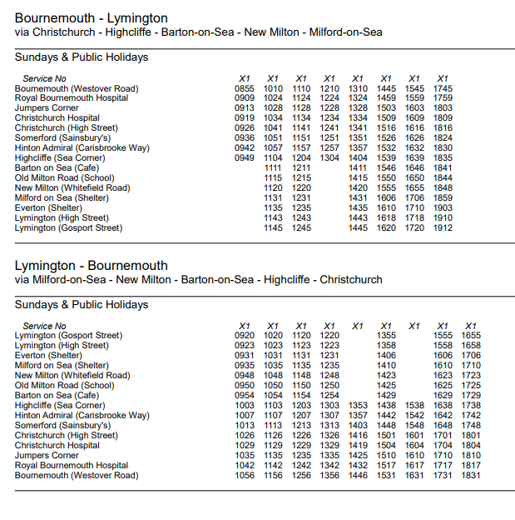Bus X1 timetable for Sunday 9th June 2024 only.

